12. To study the SSL protocol by capturing the packets using Wireshark tool while visiting anySSL secured website (banking, e-commerce etc.).

1.Open Wireshark first
2.Open Amazone and login
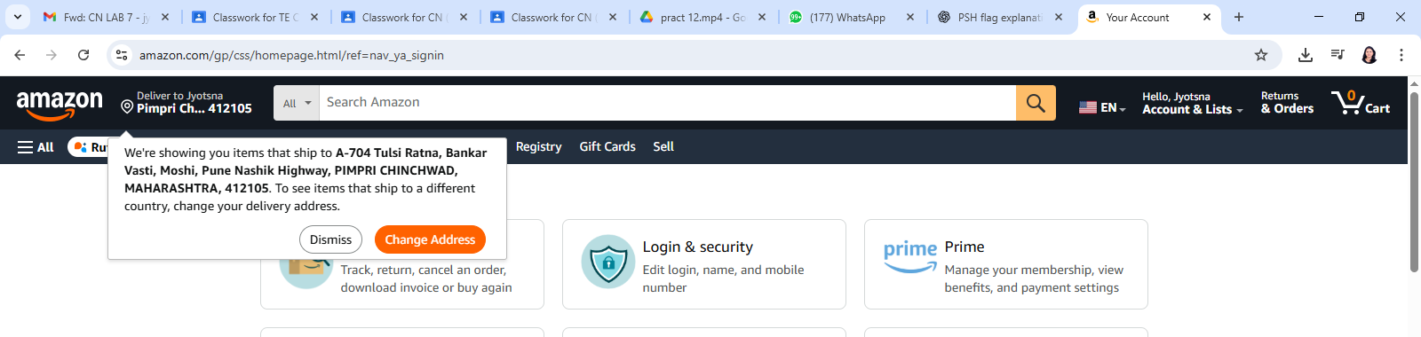
3.Stop packet capturing on wire shark
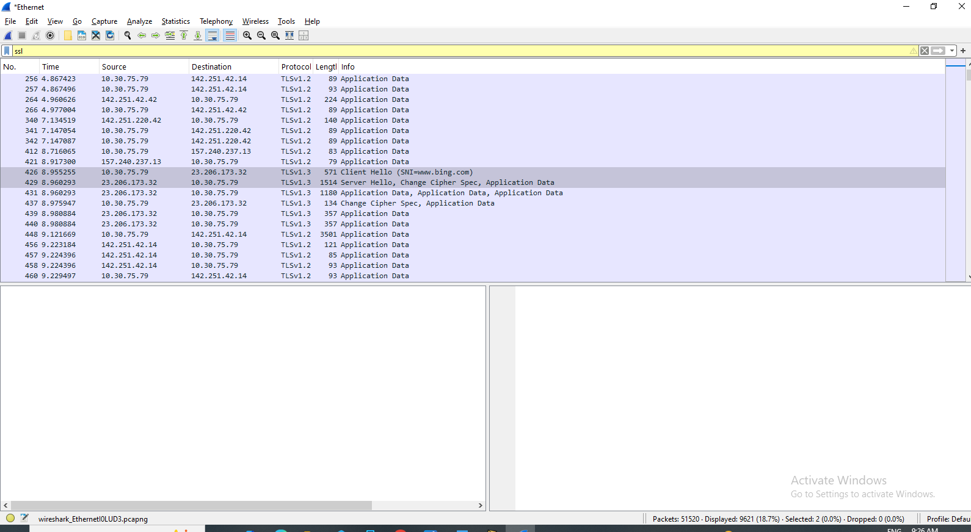

4.Right click Click on > Client hello follow TLS Stream you will get popup close that
by doing this you will get one command on Wireshark as follow

tcp.stream eq 20
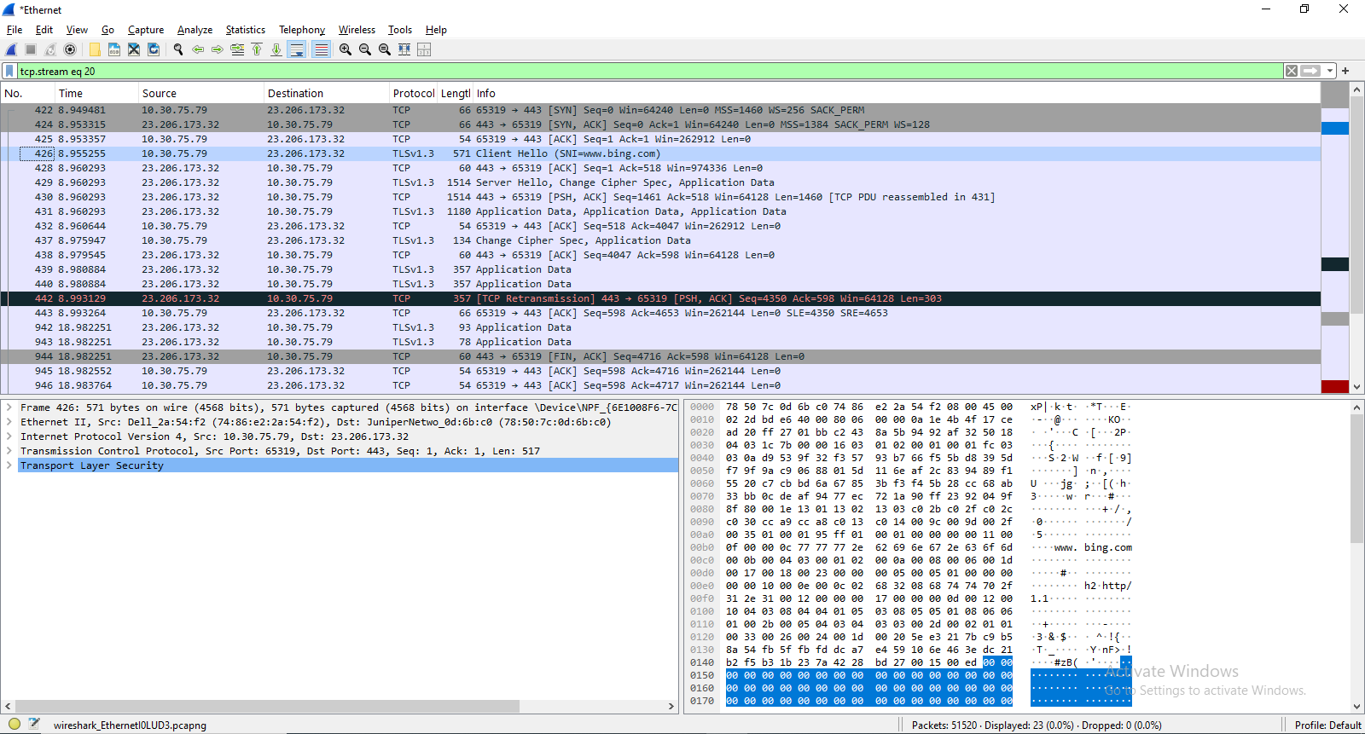

5. tcp.stream eq 20 && ssl
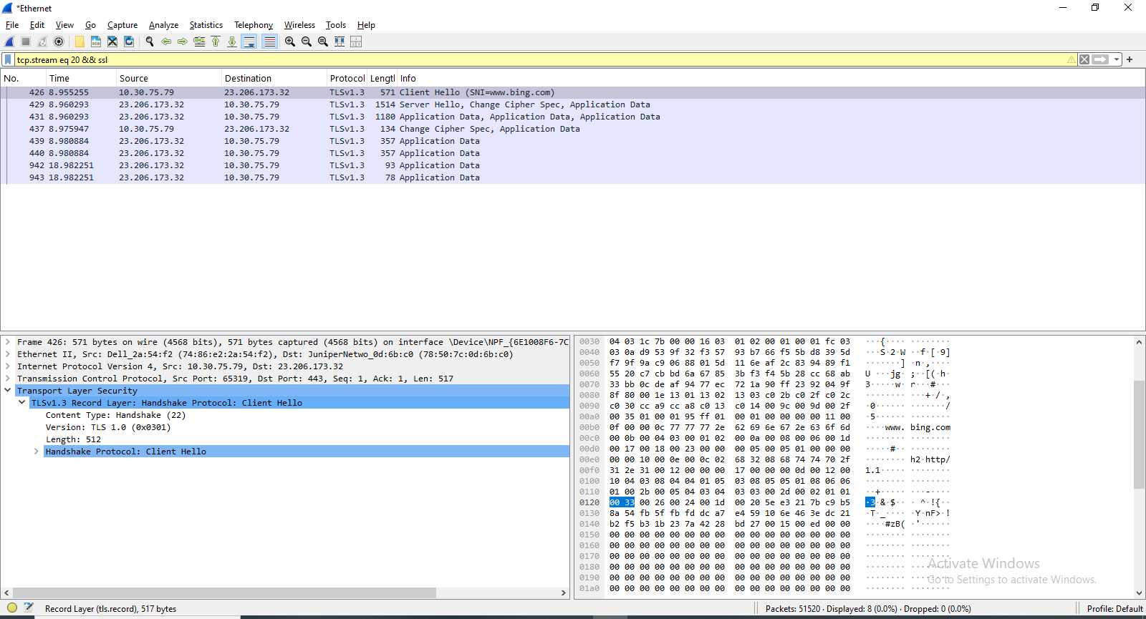
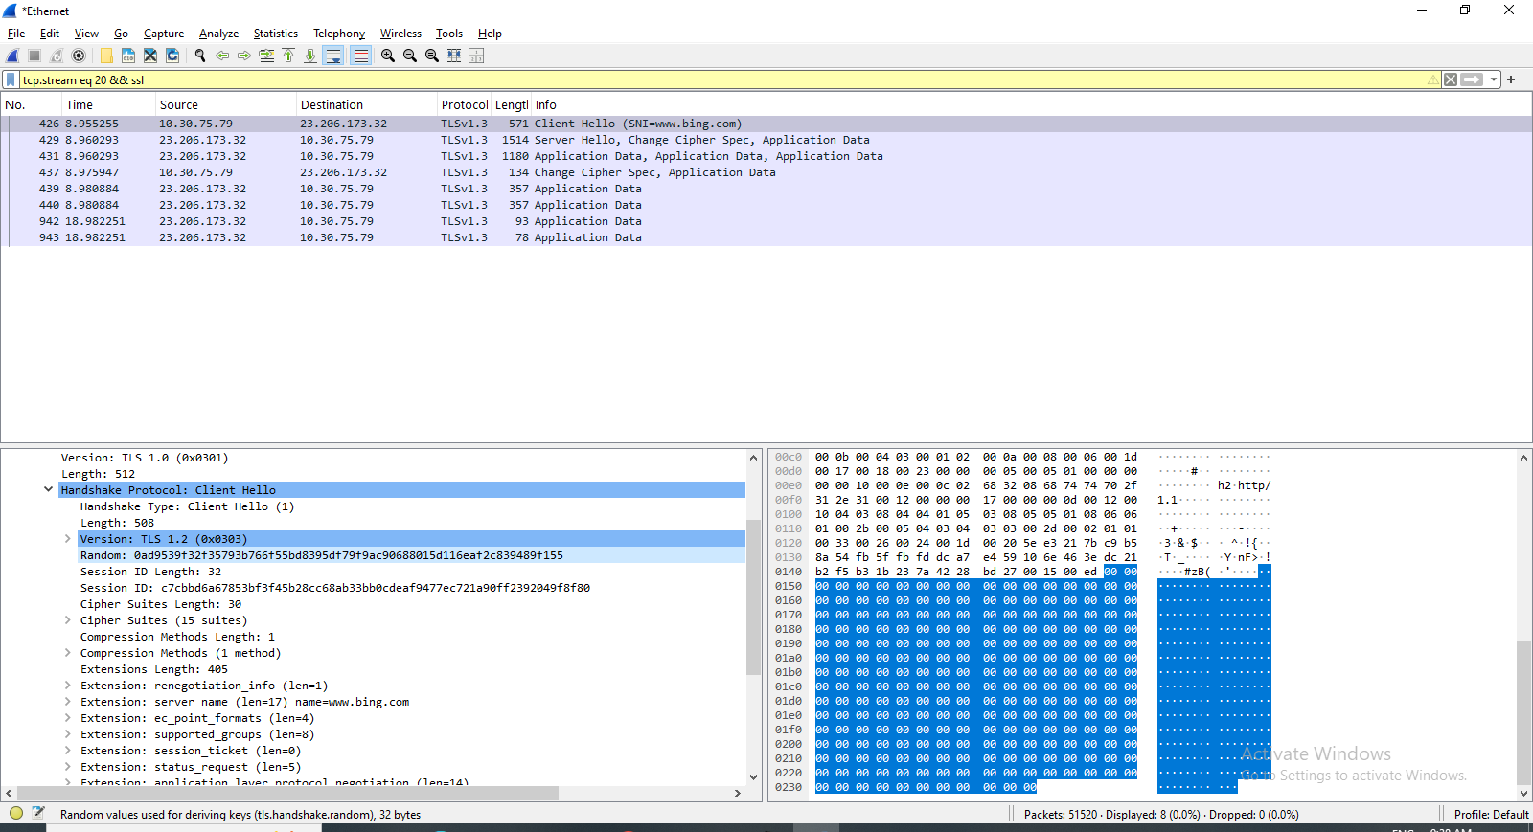
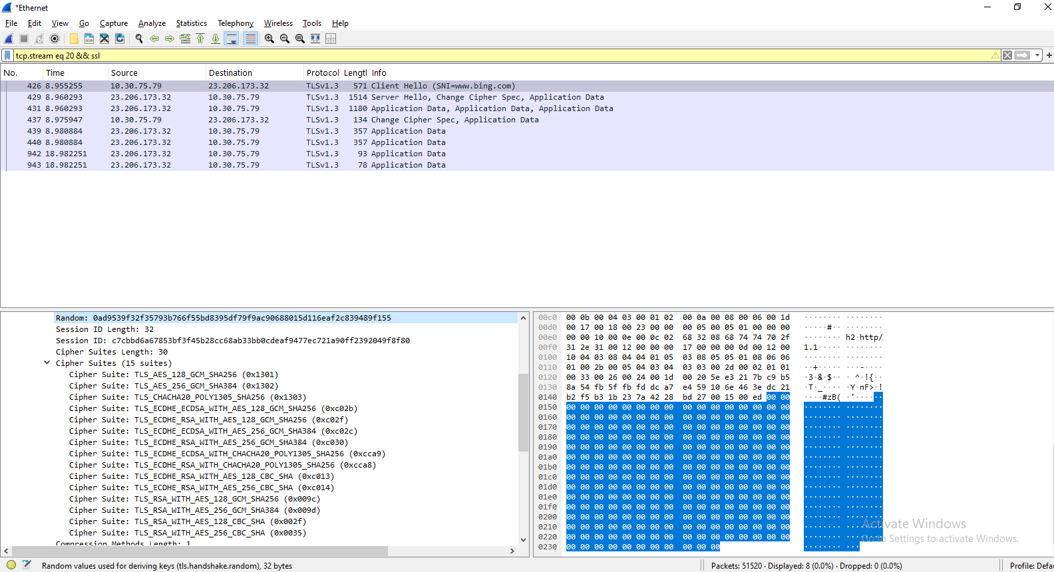
(Click on bottom Transport layer security thrn again click on arrow you will get all details )

7.If you do right click on server hello follow TLS Stream you will get popup close that
by doing this you will get one command on Wireshark as follow
